Memorandum

|  |  |
| --- | --- |
| To: | New Gamer(s) at UWB |
| From: | Odiscious Dozier |
| cc: | Professor Laurie Anderson, Ph.D. |
| Date: | July 2, 2014 |
| Re: | Deciding between Halo 4 and Dishonored |
|  |  |

<http://seattle.craigslist.org/see/npo/4561555214.html> - summer activist job

INTRODUCTION

Halo 4 and Dishonored are games that can be played on a PC, but you will have to choose between them based on your playing preferences. The games are both highly rated; however, there are significant differences between the games. This memo is designed to help you, as a student, decide which game might best fit your entertainment needs or desires. It uses the following criteria: scenery, interactions, weapons, and ratings.

BODY

SCENERY

Halo 4 takes the player on a campaign journey throughout the universe. Combat is done on various worlds and in mostly moderate weather conditions. The focus of galactic battle keeps the environments alternating between calm and peaceful settings to global attacks of catastrophic destruction. The individual player is subject to all conditions.

Dishonored is a game that focuses on the story of an individual named Corvo. The scenes are city based and the location does not change as significantly as Halo 4. The city is built uniquely, with intent. The idea is to allow the player to aggressively pursue missions on the streets of the city. Plagues and industry are incorporated to elevate sophistication of the game. Mysticism is incorporated in all areas of the game as Dishonored is centered on the supernatural.

INTERACTIONS

Halo 4 is a Massive Multi-player Online (MMO) game. “MMOGs can enable players to cooperate and compete with each other on a large scale, and sometimes to interact meaningfully with people around the world.” [1] This is exactly what Halo 4 does, but it also allows for single player campaigns, which incorporate the use of Artificial Intelligence (A.I.).

Dishonored is a single player game that makes use of Artificial Intelligence, only, and offers no multi-player gaming abilities or attributes. Any major decision points the player makes during game play will affect the story of the campaign and the fate of the empire within the game. While there is no option for interacting with other players from around the world, there is the availability to download game-content. Downloading game content adds to the game play; for example, new scenes, weapons, and abilities.

WEAPONS

Halo 4 is equipped with a complete set of human technology and weapons that are likely to be seen in today’s army; for example, assault rifle, sniper rifle, hand grenades, and magnum hand pistol. There is also an equal amount of alien technology and weapons. Each weapon has been upgraded from previous versions of the game and made more realistic. All effects of the weapons have been refactored to be more realistic in reaction and striking forces; thus, enhancing game play.

Weapons list for humans (Battle rifle, Assault rifle, DMR [Designated Marksman Rifle], Sniper rifle, Rocket Launcher, Magnum [pistol], Shot gun, Rail gun, Squadron Automatic Weapon [SAW], Spartan Laser, Sticky Detonator, and Grenade).

Weapons list for Covenant (Covenant Carbine, Plasma Pistol, Needler, Energy Sword, Storm rifle, Beam rifle, Concussion rifle, Gravity Hammer, and Plasma Grenade)

Weapons list for Prometheans (Binary rifle, Bolt shot, Incineration Canon, Light rifle, Pulse grenade, Scatter shot, and Suppressor)[2]

Dishonored game play takes you beyond the weapons of hand to hand combat and modern mechanical weapons to the supernatural. Haunting your enemies is a concept that is reveled in this game.

Weapons List (Corvo’s Fold-away Sword (Melee), Crossbow (Ranged), Longbow (Ranged), Normal Swords (Melee), Wheellock Pistol (Ranged), Grenade, Spring Razor Mine, and Sticky Grenades)

Supernatural Abilities (The Heart – Objective/Item detector, Blink – Teleport short-long distances, Dark Vision – Improves vision, Devouring Swarm – Summons attack-rats, Healing – Heals injuries, Possession – Controls sentient beings, Bend Time – Stops time, for a limited time, Wind Blast – Creates a gust of wind, Celerity – Accelerates your speed at the expense of blurred vision, Feather – Fall from greater distances without injury, Agility – Jump greater distances and sprint faster, Shadow Kill – Turns dead enemies into dust to avoid discovery.

RATINGS

Halo 4 has won over 30 industry awards in 2012. Halo 4 won awards like: Best Xbox 360 Multi-player game, Best Xbox 360 Game, Best Overall Multi-player Game, Best Overall Graphics, and Best Overall Sound. Upon its release, Halo 4 earned a gross figure of $220 million, on its first day, and $300 million in its opening week. [3]

Dishonored was a winner of over 50 E3 awards. Dishonored won awards like: Best Action-Adventure Game, and Best Game. “On November 28, 2012, Bethesda indicated that sales were exceeding their expectations and that as a result, they intended to develop Dishonored into a franchise.”[4]

Table 1 illustrates the criterion for each game.

Table Halo 4 and Dishonored at a glimpse

|  |  |  |
| --- | --- | --- |
| **Criterion** | **Single player – online downloadable content**  **(Dishonored)** | **Massive Multi-player Online Experience**  **(Halo 4)** |
| **Ratings** | Winner of over 50 E3 awards | Winner of over 30 industry awards |
| **How long to have fun?** | Able to skip dialogue, extremely detailed environment, long story mode, gaming within 5mins[6] | 4 minutes ‘til emotional response. Game play in less than 10mins.[5] |
| **Controller/movement difficulty?** | Same | Same |
| **Game play difficulty? Are weapons hard to use?** |  |  |
| **Scenery** | City | Worlds |

CONCLUSION

When selecting your next video game purchase, remember that Halo 4 and Dishonored both differ in their scenery, their interactions (human or artificial intelligence), their weapons, and their ratings.

If you are a gamer who enjoys a stealthy single player experience, Dishonored is the clear option since Halo 4 was built for a massive multi-player online experience.

If you are a gamer who enjoys a greater degree of control over the fate of your character, then Dishonored is the clear option. While Halo 4 offers stealth missions, they are minimal – at best.

If speed and accuracy are areas of concern, you will want to purchase Halo 4. Dishonored has been built for the individual player who enjoys a slower progression through game play and offers minimal sniper opportunities.

References

[1] <http://en.wikipedia.org/wiki/Massively_multiplayer_online_game>

[2] <http://www.nowgamer.com/cheats/halo-4-weapons-guide/1665557/halo_4_weapons_guide_human_covenant_promethean.html>

[3] <http://en.wikipedia.org/wiki/Halo_4>

[4] <http://en.wikipedia.org/wiki/Dishonored>

[5] <https://www.youtube.com/watch?v=iTR1VJoJZVQ&feature=kp>

[6] <https://www.youtube.com/watch?v=XnMcK-1dclE>

[7] <http://guides.gamepressure.com/dishonored/guide.asp?ID=17371>

[8] <https://www.google.com/search?q=halo+4+controller+layout&espv=2&tbm=isch&tbo=u&source=univ&sa=X&ei=WSDAU_W6Eqr3iwKAzYHoBw&ved=0CBwQsAQ&biw=1746&bih=890#facrc=_&imgdii=_&imgrc=tQcEj6suk1GI9M%253A%3BlX1DmfZHLe0MTM%3Bhttp%253A%252F%252Fwww.gameranx.com%252Fimg%252F12-Aug%252Fhalo-4-recon-button-layout.jpg%3Bhttp%253A%252F%252Fwww.gameranx.com%252Fupdates%252Fid%252F8950%252Farticle%252Fhalo-4-button-layouts-revealed-and-detailed%252F%3B638%3B417>

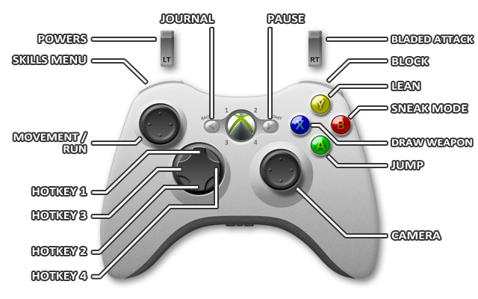

Figure [7]

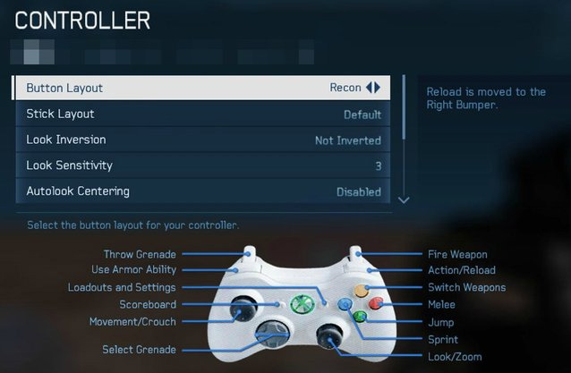

Figure [8]